**Import Excel Data into MS Access File**

Initial Data:

* Input excel file with 2000 rows and 30 columns.
* MS Access file with no table.

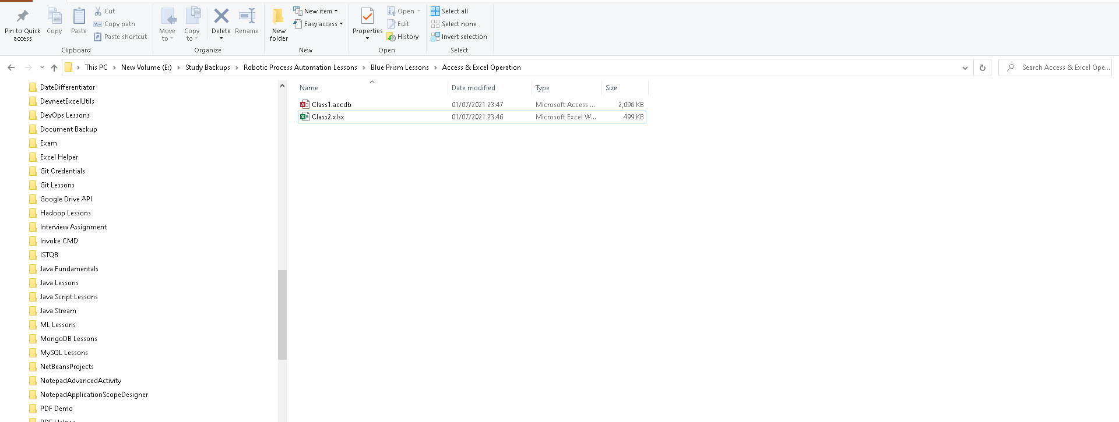

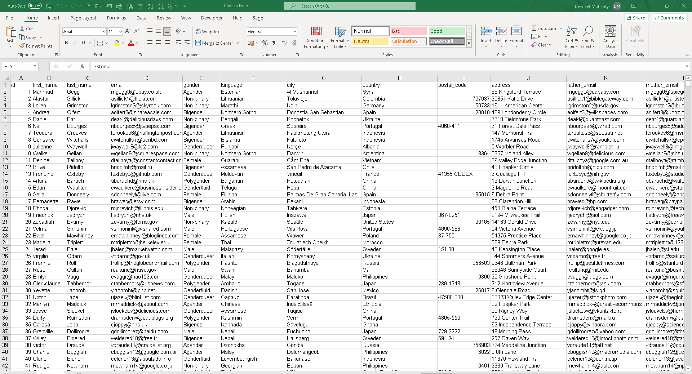



Inputs for the flow page:

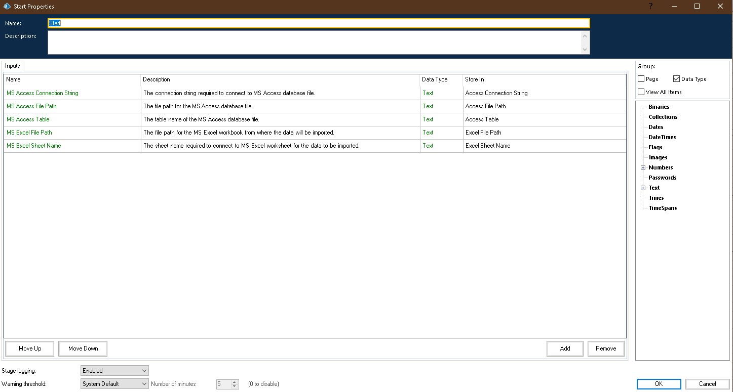

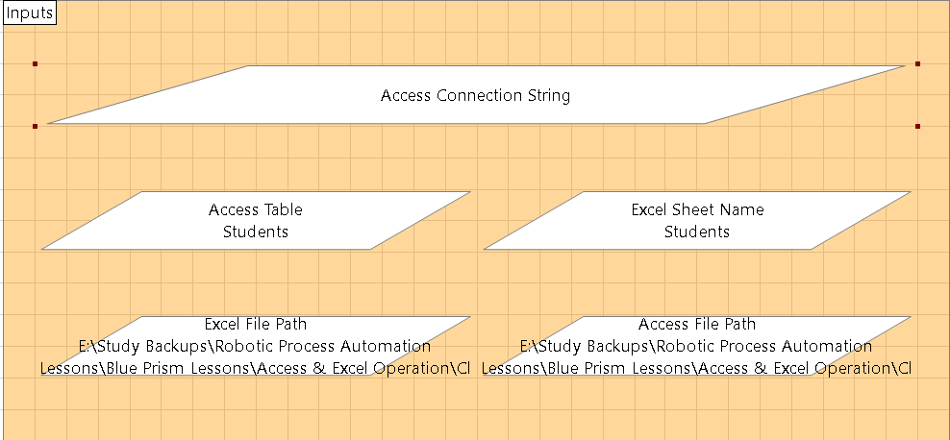

Flow Steps:

**Step I:** Set connection string for Access Database File.

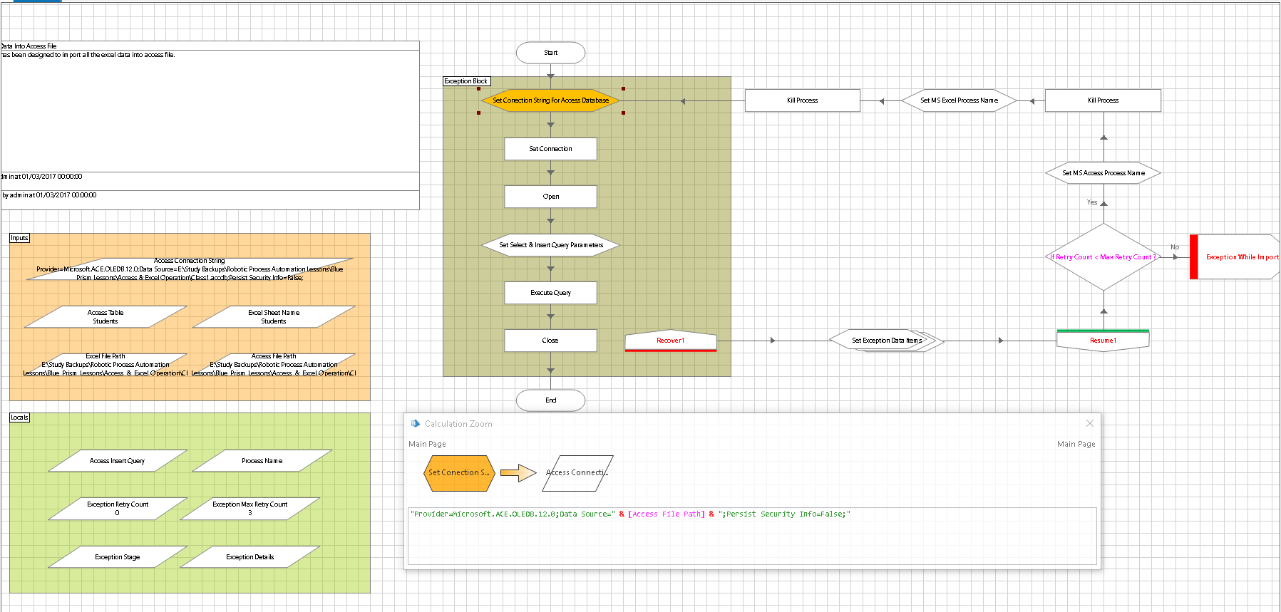

**Step II:** Set connection with MS Access Connection String using Set Connection action of the business object: Data – OLEDB.

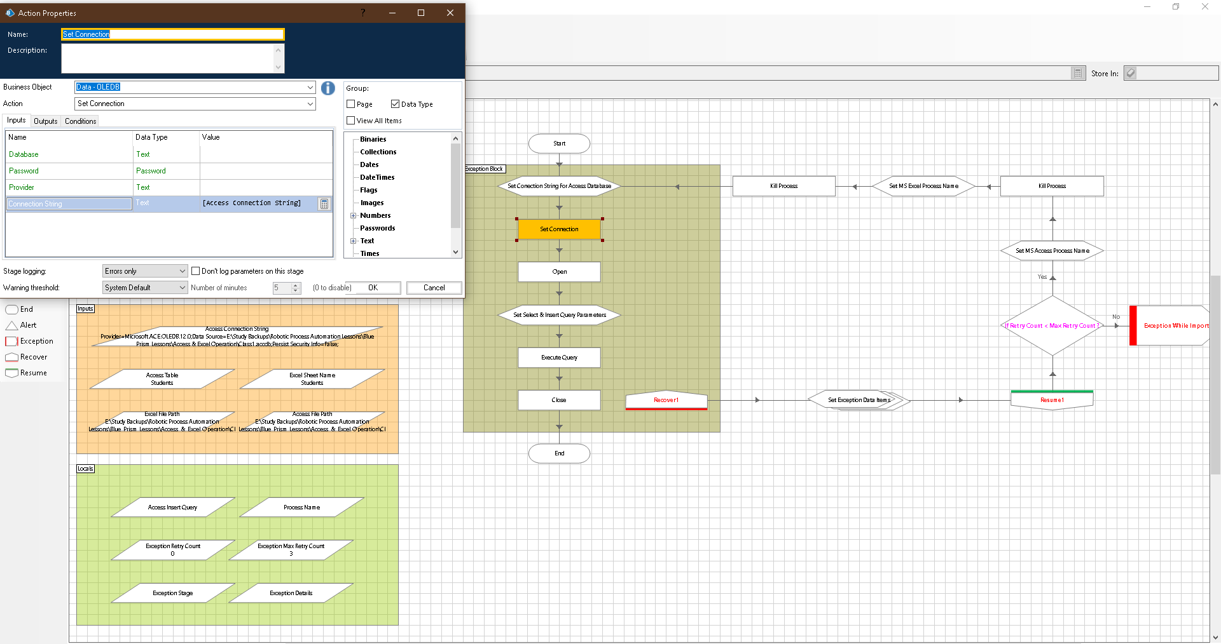

**Step III:** Open MS Access Connection using Open action of the business object: Data – OLEDB.

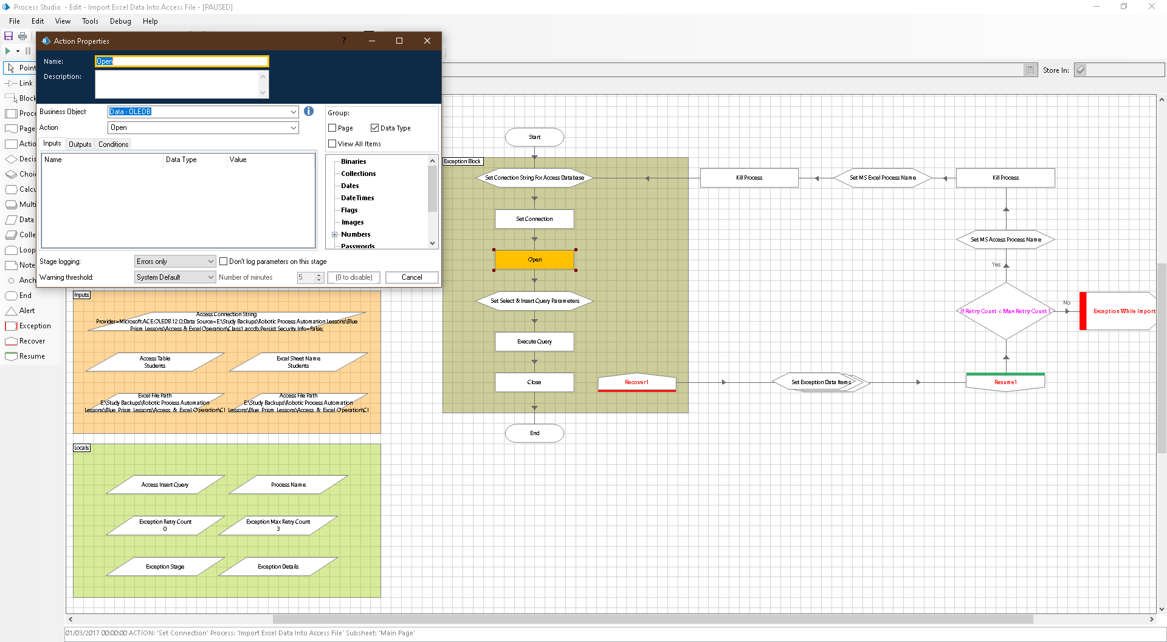

**Step IV:** Set OLEDB Query to import entire excel data table into MS Access database with a custom table name.

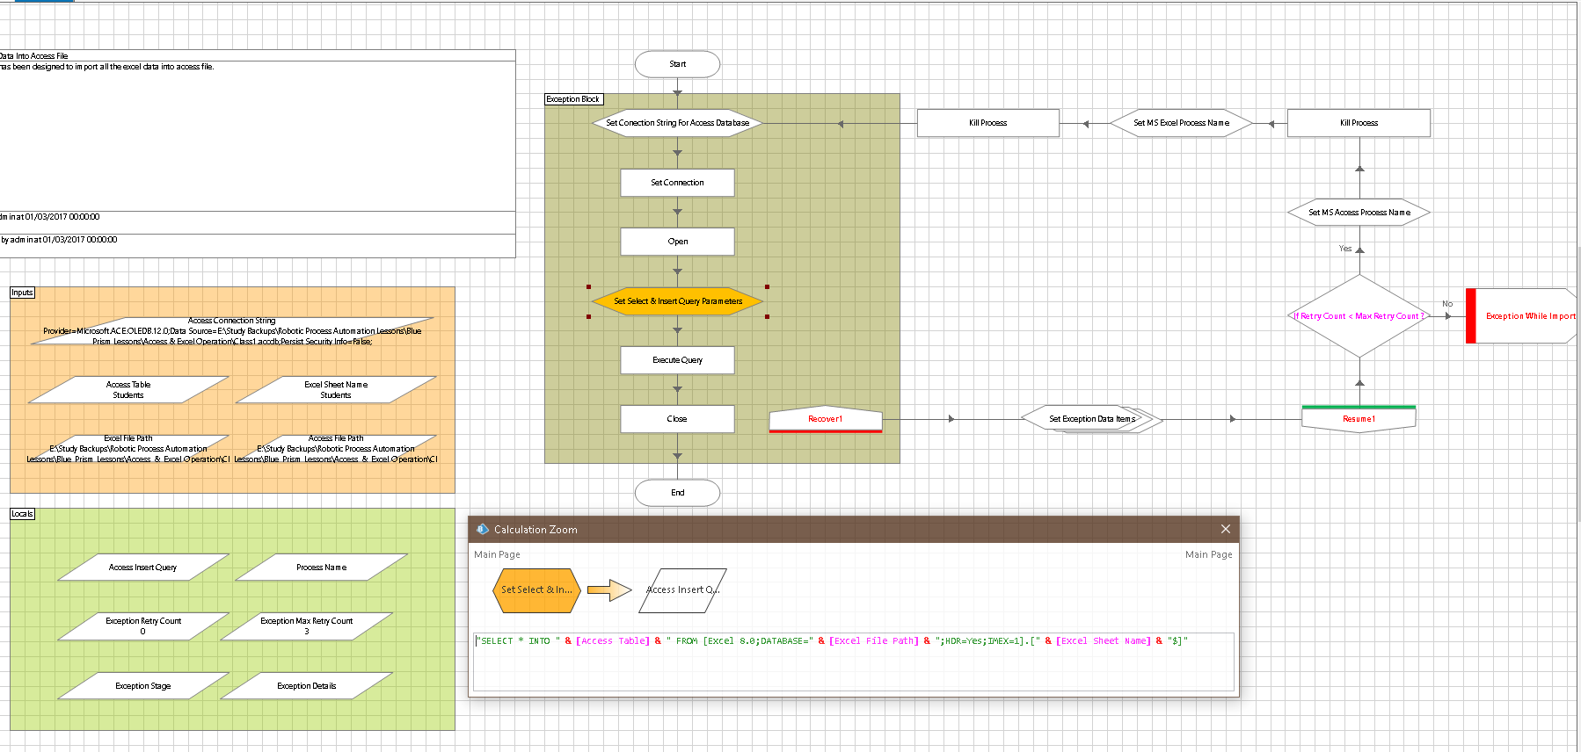

**Step V:** Execute the OLEDB query prepared in the above step using Execute action of the business object: Data – OLEDB.

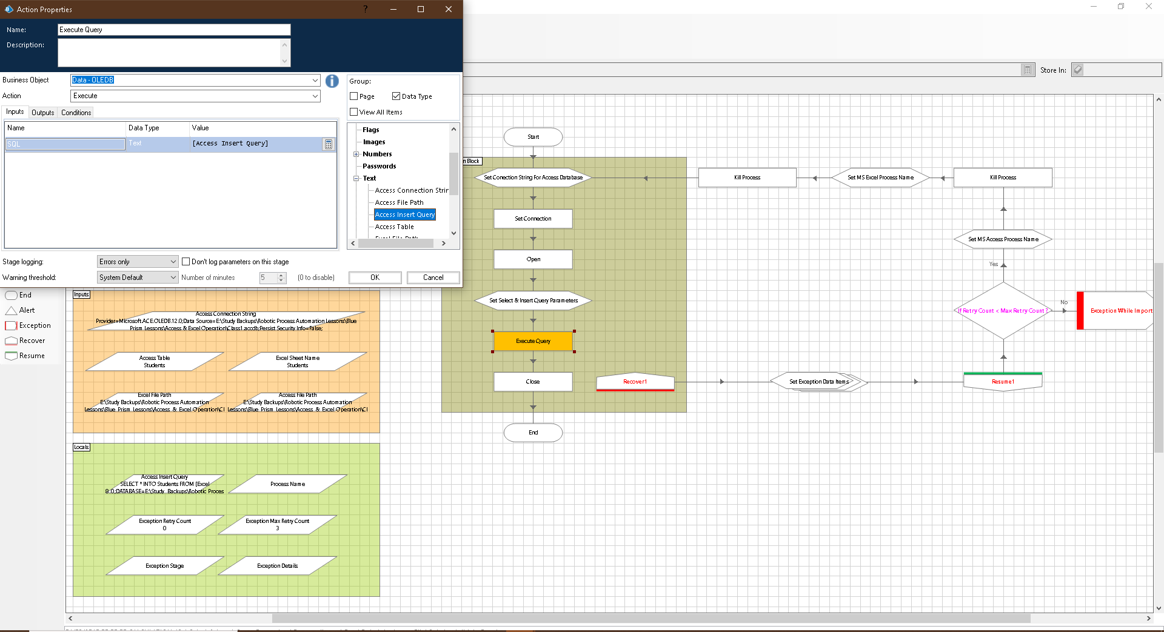

**Step VI:** Close the OLEDB query connection using Close action of the business object: Data – OLEDB.

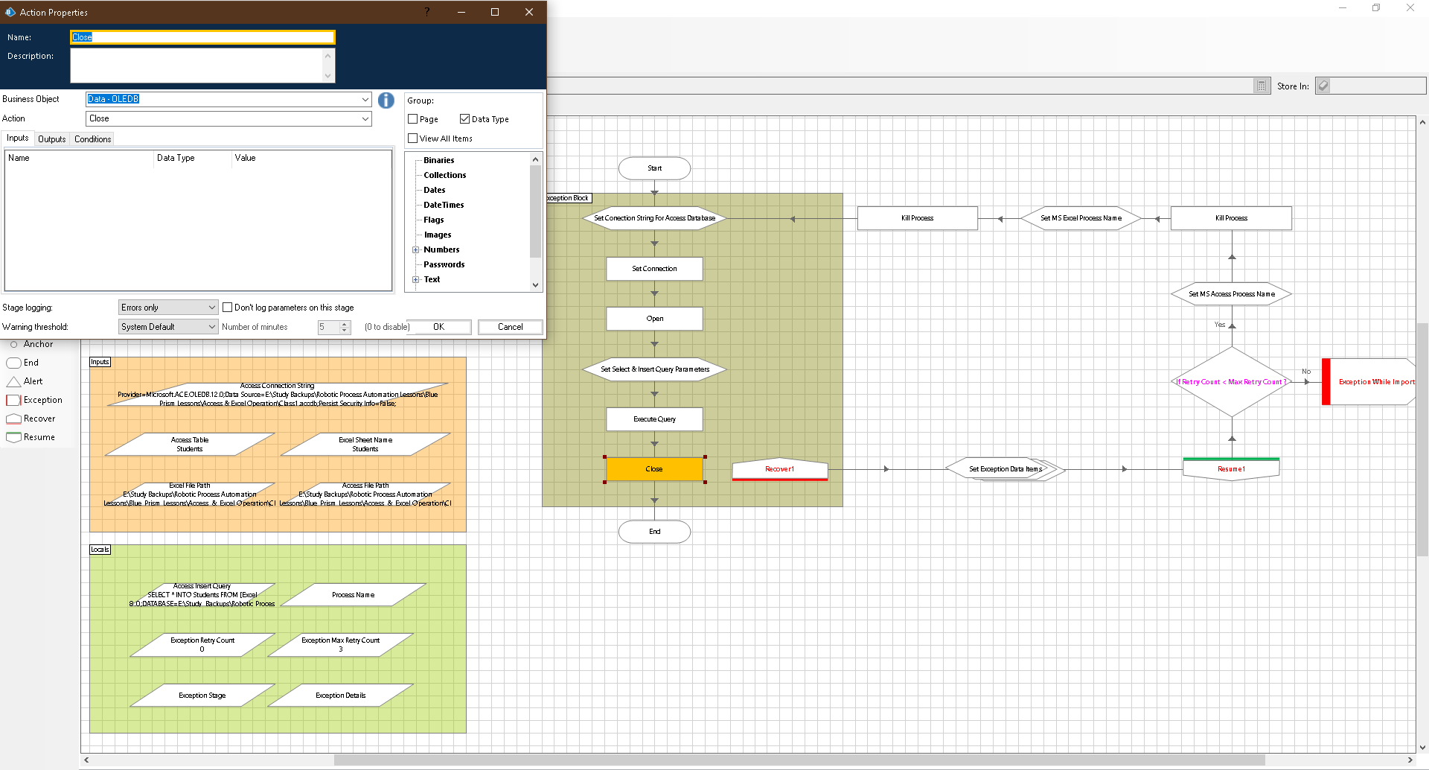

**Final Output:**

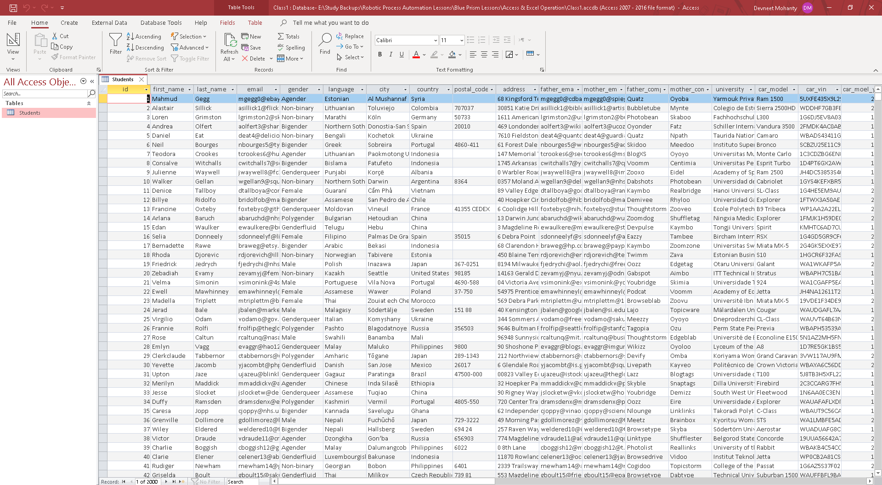

**Execution Speed:** It takes less than a second when ran from Control Room to insert entire excel table of 2000 records and 30 columns within 1 second.

